Unimeet – Faculty Appointment Management System

1. Introduction
In many universities and colleges, students often face difficulties when trying to meet faculty members for academic guidance, project discussions, attendance issues, career advice, or personal mentoring. Traditional appointment methods such as emails, phone calls, or direct visits are unorganized and may lead to scheduling conflicts, missed appointments, and unnecessary waiting time.
Unimeet is developed to solve these issues by providing a centralized online platform where students can easily book appointments with faculty members based on available time slots. The system improves communication, saves time, and ensures better scheduling management.

2. Description
Unimeet is a web-based Faculty Appointment Management System developed using the MERN Stack (MongoDB, Express.js, React.js, Node.js). The main goal of this platform is to simplify the communication and meeting process between students and faculty members in colleges and universities. In many educational institutions, students usually depend on emails, phone calls, or direct visits to schedule meetings with faculty. This traditional process is often time-consuming, unorganized, and may create confusion regarding faculty availability.
Unimeet provides a centralized platform where faculty members can create their own profiles, define their available time slots, and manage appointment schedules. Students can log into the system, search for faculty members based on department or subject, check available slots, and book appointments according to their convenience. Once the appointment is booked, the system automatically updates slot availability so that no other student can book the same slot, thereby preventing double booking conflicts.
The platform also includes appointment approval and rejection functionality. Faculty members can review student requests and decide whether to approve, reject, or reschedule the appointment. If a faculty member is unavailable for a specific time slot, they can update or cancel the schedule, and the system will notify the student automatically. Students can also cancel or modify their appointments if their plans change.
Unimeet maintains complete records of all appointments, including meeting purpose, date, time, faculty details, student details, and appointment status. This helps both students and faculty review previous meetings whenever needed. The system can also generate reports related to appointment frequency, faculty workload, and student interaction statistics.

3. Scenario-Based Case Study
Ravi is a final-year student who wants to discuss his project progress with his faculty guide. Instead of waiting outside the faculty room or sending multiple emails, Ravi uses Unimeet to schedule an appointment.
- User Registration/Login: Ravi logs into the system using his student credentials.
- Faculty Search: He searches for his project guide in the faculty list.
- View Available Slots: Ravi checks the available appointment timings.
- Book Appointment: He selects a suitable date and time slot and enters the meeting purpose.
- Confirmation Notification: The faculty member receives the request and approves it. Ravi receives a notification confirming the appointment.
- Appointment Management: Ravi can view, update, or cancel the appointment if needed.
- Appointment History: After the meeting, the appointment details are stored in the system for future reference.

4. Technical Architecture
The Unimeet platform consists of the following components:
- User Interface: Provides responsive pages for students and faculty to manage appointments.
- Frontend Application: Built with React.js to provide smooth navigation and booking functionality.
- Backend Server: Built with Node.js and Express.js to handle business logic and APIs.
- Authentication Service: Handles secure login, registration, and role-based access for students and faculty.
- Appointment Scheduling Service: Manages available slots, bookings, cancellations, and updates.
- Notification Service: Sends booking confirmation, reminder, cancellation, and approval notifications.
- Database: Stores user details, faculty schedules, appointments, and notifications in MongoDB.
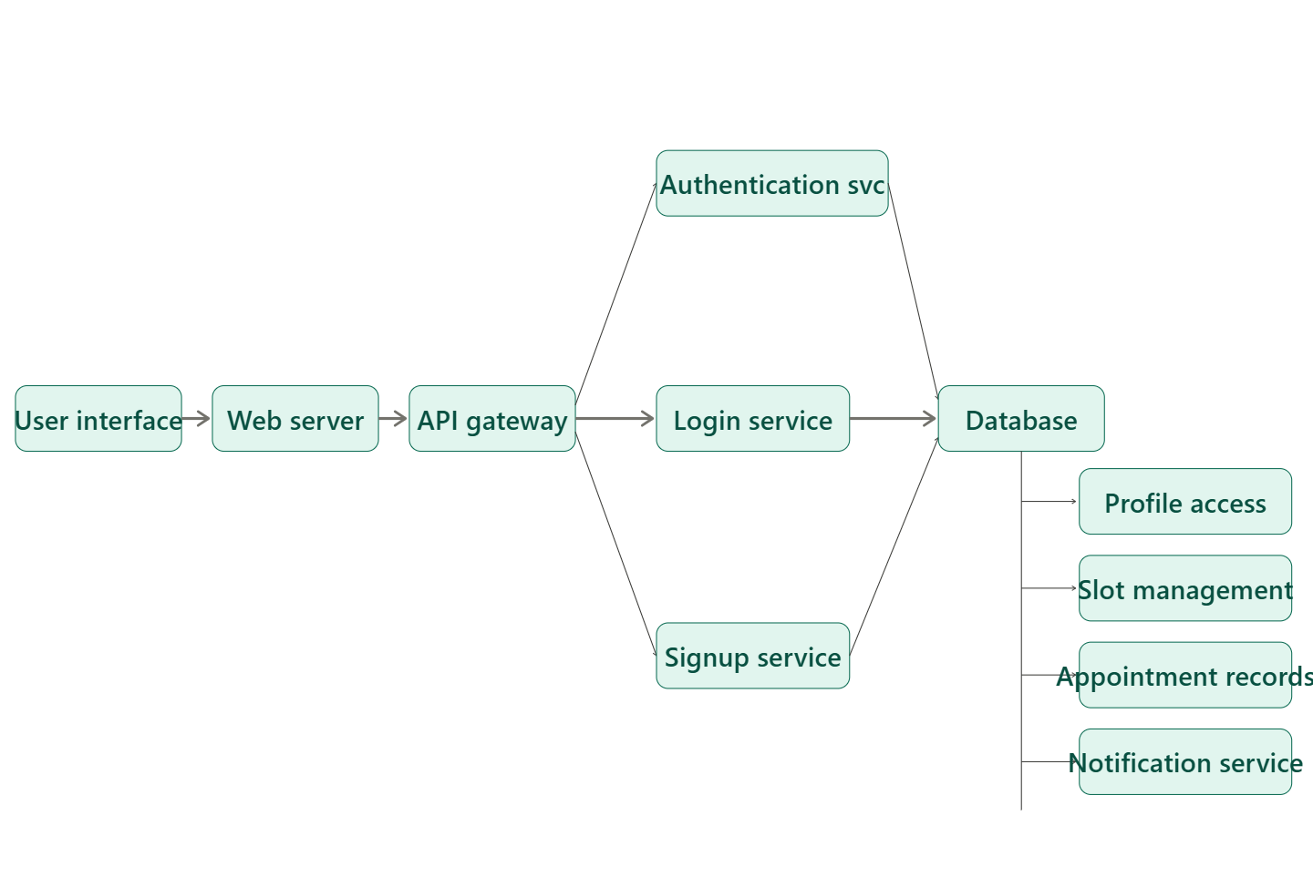
- Admin Panel: Allows administrators to monitor users, faculty records, and appointment statistics.

5. ER-Diagram & Relationships
The major entity relationships in Unimeet are:
- Student-Appointment Relationship: One student can book multiple appointments.
- Faculty-Appointment Relationship: One faculty member can receive multiple appointment requests.
- Faculty-Time Slot Relationship: One faculty member can create multiple available time slots.
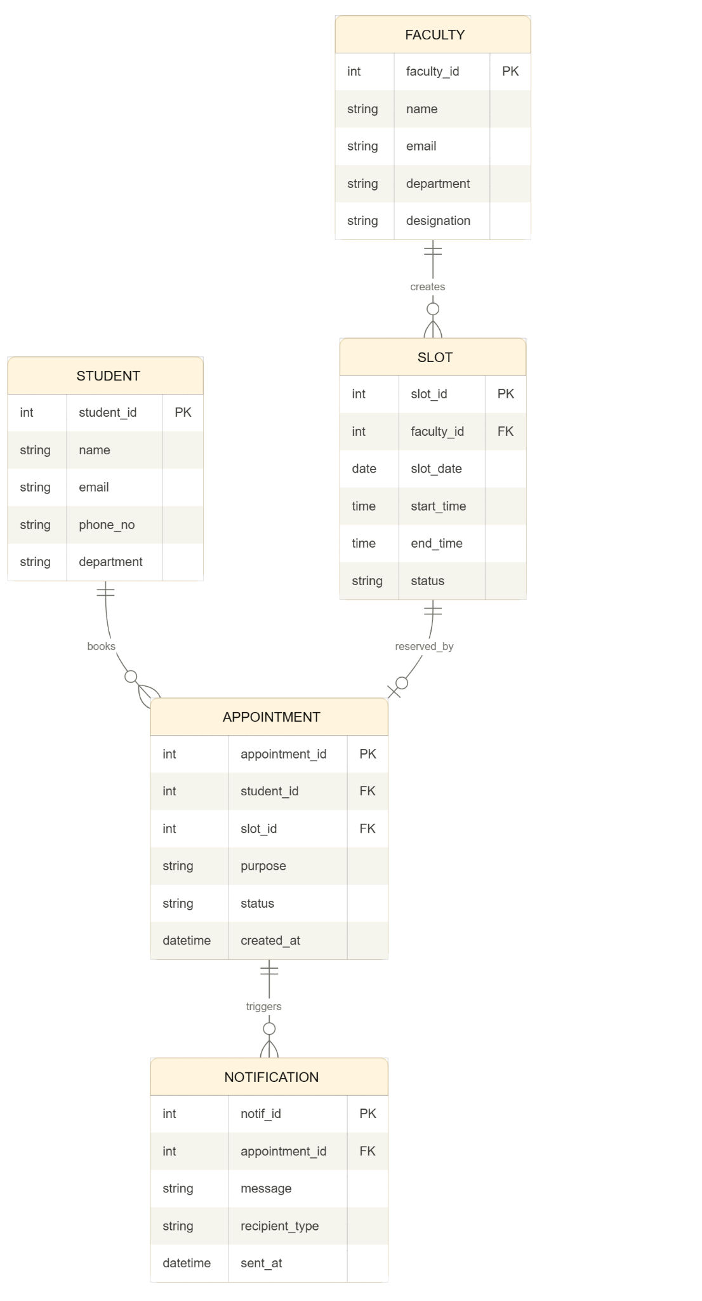
- Appointment-Notification Relationship: Each appointment can generate multiple notifications.
These relationships help maintain a structured scheduling system and avoid booking conflicts.

6. Project Flow
Student registers/logs in → Searches for faculty → Views available slots → Selects date and time → Enters appointment purpose → Submits booking request → Faculty receives notification → Faculty approves/rejects request → Student receives confirmation → Appointment is stored in history.
Faculty logs in → Creates available slots → Views student appointment requests → Approves/rejects appointments → Updates slot availability → Maintains appointment records.
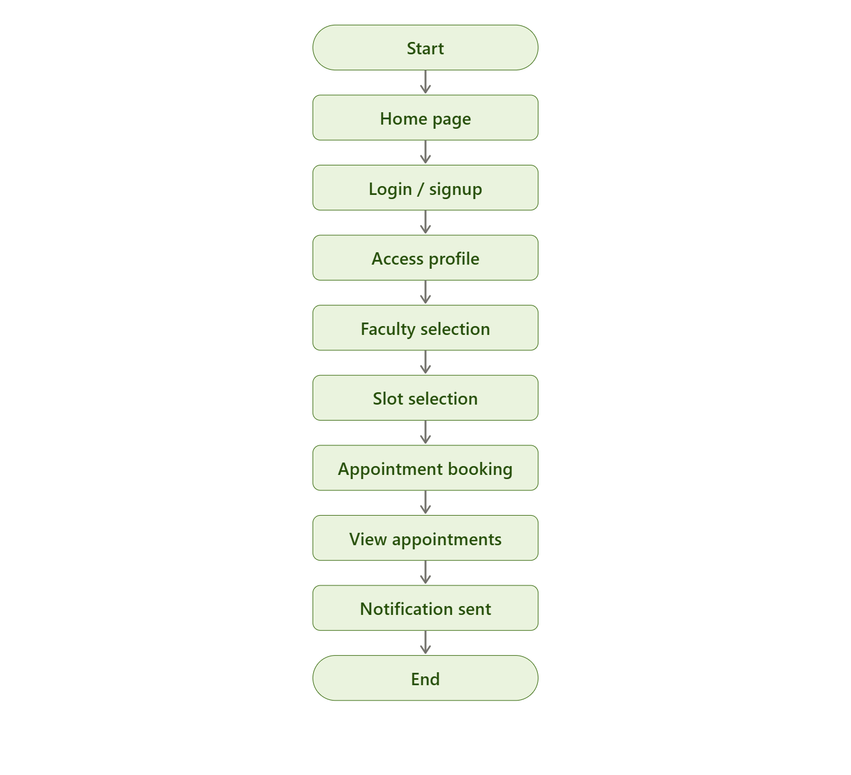
Admin logs in → Manages faculty and student accounts → Monitors appointments → Generates reports → Handles complaints and issues.

7. Pre-Requisites
Students should know:
- Basics of JavaScript
- ES6 Concepts
- Node.js fundamentals
- Express.js basics
- MongoDB basics
- REST APIs
- Basic React
- JSON handling
- Authentication basics
- CRUD Operations

8. Required Technologies
- Frontend: React.js, HTML, CSS
- Backend: Node.js, Express.js
- Database: MongoDB
- Authentication: JWT, bcrypt
- Tools: Postman, Git, GitHub
- Optional: Nodemailer for email notifications
- Optional: Socket.io for real-time notifications

9. Suggested Database Collections

Users Collection
{
"name": "Ravi Kumar",
"email": "ravi@example.com",
"password": "hashed_password",
"role": "student"
}

Faculty Collection
{
"facultyName": "Dr. Sharma",
"department": "Computer Science",
"email": "drsharma@example.com",
"availableSlots": ["10:00 AM", "11:00 AM"]
}

Appointments Collection
{
"studentId": "student_id_reference",
"facultyId": "faculty_id_reference",
"date": "2026-04-15",
"timeSlot": "10:00 AM",
"purpose": "Project Discussion",
"status": "Pending"
}

Notifications Collection
{
"userId": "user_id_reference",
"message": "Your appointment has been confirmed",
"type": "appointment",
"isRead": false
}

Time Slots Collection
{
"facultyId": "faculty_id_reference",
"date": "2026-04-15",
"timeSlot": "11:00 AM",
"status": "Available"
}

10. Key Features
- User Authentication (Student/Faculty/Admin Login)
- Faculty Profile Management
- Faculty Time Slot Creation
- Appointment Booking System
- Conflict-Free Scheduling
- Appointment Approval/Rejection
- Appointment Cancellation and Rescheduling
- Notification System
- Appointment History
- Role-Based Access Control
- Admin Dashboard
- Reports and Analytics

11. Optional Advanced Features
- Email Notifications using Nodemailer
- SMS Notifications
- Real-Time Booking Updates using Socket.io
- Calendar Integration
- Google Meet / Zoom Meeting Links
- QR Code for Appointment Verification
- Department-Wise Faculty Filtering
- Chat Feature between Student and Faculty
- Feedback and Rating System
- PDF Export of Appointment Reports

12. Learning Outcomes
By completing this project, students will learn:
- Full Stack Development (Frontend + Backend)
- REST API Design
- Authentication and Authorization using JWT
- MongoDB Database Design
- Real-Time Scheduling System
- Role-Based Access Control
- CRUD Operations
- Notification Management
- React State Management
- Real-world Project Structure
- Deployment Basics

13. Roles and Responsibilities

Student
- Register and login securely
- Search for faculty members
- View available time slots
- Book appointments
- Update or cancel appointments
- View appointment history
- Receive notifications

Faculty
- Register and login securely
- Create and manage available slots
- Approve or reject appointment requests
- View upcoming appointments
- Maintain appointment records
- Send updates to students

Admin
- Manage student and faculty accounts
- Monitor appointment records
- Handle complaints and issues
- Generate reports and analytics
- Maintain overall system performance

14. Project Structure

Frontend Structure
client/
│
├── public/
│ ├── index.html
│ ├── favicon.ico
│
├── src/
│ ├── assets/
│ │ ├── images/
│ │ ├── icons/
│ │
│ ├── components/
│ │ ├── Navbar.js
│ │ ├── Sidebar.js
│ │ ├── Footer.js
│ │ ├── FacultyCard.js
│ │ ├── AppointmentCard.js
│ │ ├── NotificationCard.js
│ │
│ ├── pages/
│ │ ├── Home.js
│ │ ├── Login.js
│ │ ├── Register.js
│ │ ├── FacultyList.js
│ │ ├── FacultyProfile.js
│ │ ├── BookAppointment.js
│ │ ├── AppointmentHistory.js
│ │ ├── Notifications.js
│ │ ├── StudentDashboard.js
│ │ ├── FacultyDashboard.js
│ │ ├── AdminDashboard.js
│ │
│ ├── services/
│ │ ├── api.js
│ │ ├── authService.js
│ │ ├── facultyService.js
│ │ ├── appointmentService.js
│ │ ├── notificationService.js
│ │
│ ├── context/
│ │ ├── AuthContext.js
│ │ ├── AppointmentContext.js
│ │
│ ├── utils/
│ │ ├── validators.js
│ │ ├── helperFunctions.js
│ │
│ ├── App.js
│ ├── index.js
│ ├── routes.js
│
├── package.json

Backend Structure
server/
│
├── config/
│ ├── db.js
│ ├── jwtConfig.js
│
├── controllers/
│ ├── authController.js
│ ├── facultyController.js
│ ├── appointmentController.js
│ ├── notificationController.js
│ ├── adminController.js
│
├── models/
│ ├── User.js
│ ├── Faculty.js
│ ├── Appointment.js
│ ├── Notification.js
│ ├── TimeSlot.js
│
├── routes/
│ ├── authRoutes.js
│ ├── facultyRoutes.js
│ ├── appointmentRoutes.js
│ ├── notificationRoutes.js
│ ├── adminRoutes.js
│
├── middleware/
│ ├── authMiddleware.js
│ ├── roleMiddleware.js
│ ├── errorMiddleware.js
│
├── utils/
│ ├── generateToken.js
│ ├── sendEmail.js
│
├── .env
├── server.js
├── package.json

15. Project Structure Deep Explanation

Frontend Folder Explanation
- public/ stores static files like HTML, icons, and images.
- src/assets/ contains reusable images, logos, and icons.
- src/components/ stores reusable UI components like cards, navbar, sidebar, and notifications.
- src/pages/ contains all pages such as login, register, faculty dashboard, and booking pages.
- src/services/ contains API call functions for authentication, faculty, appointments, and notifications.
- src/context/ is used for React Context API to manage authentication and appointment state globally.
- src/utils/ contains validation logic and helper functions.
- App.js manages the main routing and page rendering.

Backend Folder Explanation
- config/ stores MongoDB connection setup and JWT configuration.
- controllers/ contains business logic for faculty, appointments, notifications, and admin operations.
- models/ defines MongoDB schemas for users, faculty, appointments, notifications, and time slots.
- routes/ handles API endpoint definitions.
- middleware/ stores authentication, role verification, and error handling logic.
- utils/ contains helper functions such as token generation and email sending.
- server.js is the main entry point of the backend application.

16. Milestone-Based Development Plan

Milestone 1: Project Setup
- Setup React frontend and Node.js backend
- Configure MongoDB connection
- Create folder structure

Milestone 2: Authentication Module
- Implement signup and login functionality
- Add JWT authentication
- Create student, faculty, and admin roles

Milestone 3: Faculty Slot Management
- Create faculty dashboard
- Add slot creation and management features
- Prevent overlapping slots

Milestone 4: Appointment Booking Module
- Allow students to search faculty
- Implement booking, approval, cancellation, and rescheduling
- Store appointment history

Milestone 5: Notification System
- Send appointment confirmation and reminder notifications
- Add email or SMS notifications

Milestone 6: Admin Dashboard
- Monitor appointments and user activities
- Generate reports and analytics

Milestone 7: Testing and Deployment
- Test frontend and backend modules
- Fix bugs and optimize performance
- Deploy project using cloud hosting

